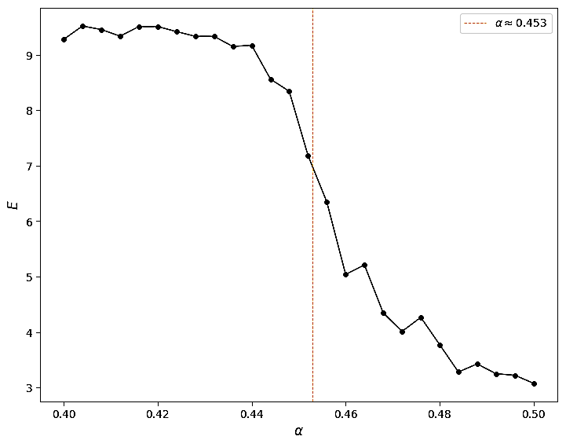 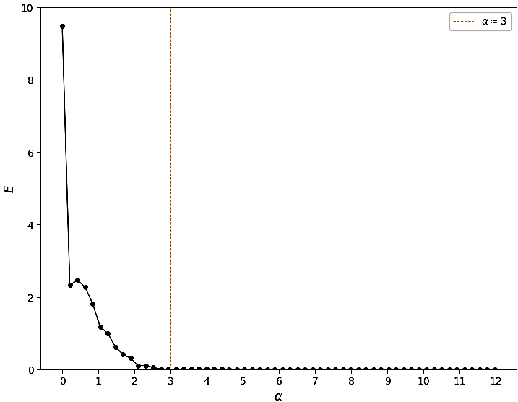

*(a) Computed synchronization errors E for range of α from 0.4 to 0.5* *(b) Computed synchronization errors E for range of α from 0 to 12*